First attached one result from running driver.py:



Format of data:

latitude degree E, longitude degree W

time, ddmm.mmmm, latDirection, dddmm.mmmm, lonDirection, altitude, utm_x E, utm_y N, zone

It shows the location belongs to zone 19T, which can be verified by the coordinate conversion online.

**Part1 – 10 mins data collected at 1 spot.**

Here attached 3 plots from Matlab showing data collected from gps for 10 minutes, all with average position marked.

Seen from these plots, I can see an approximate 13 to 14 meters of error range for both x and y axis, meaning the gps has the noise range of around 13 to 14m for various directions.

Plot1: utm_x versus utm_y

Plot2: utm_x versus utm_y with time as z axis.

Plot3: utm_x versus utm_y with altitude as z axis.

These scatter plots show the noise data approximately have a Gaussian distribution.

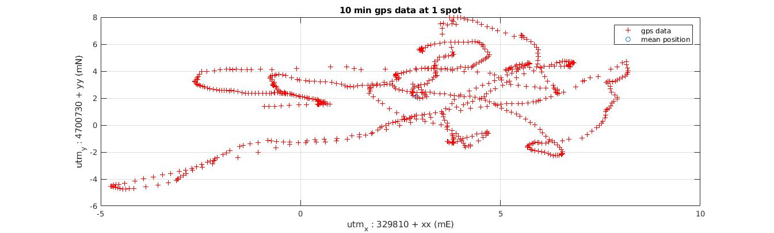

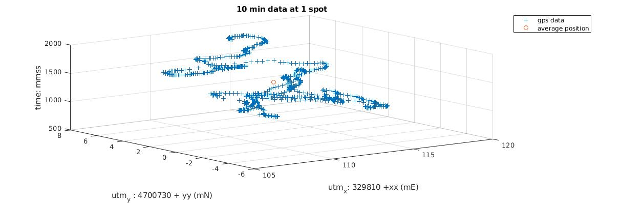

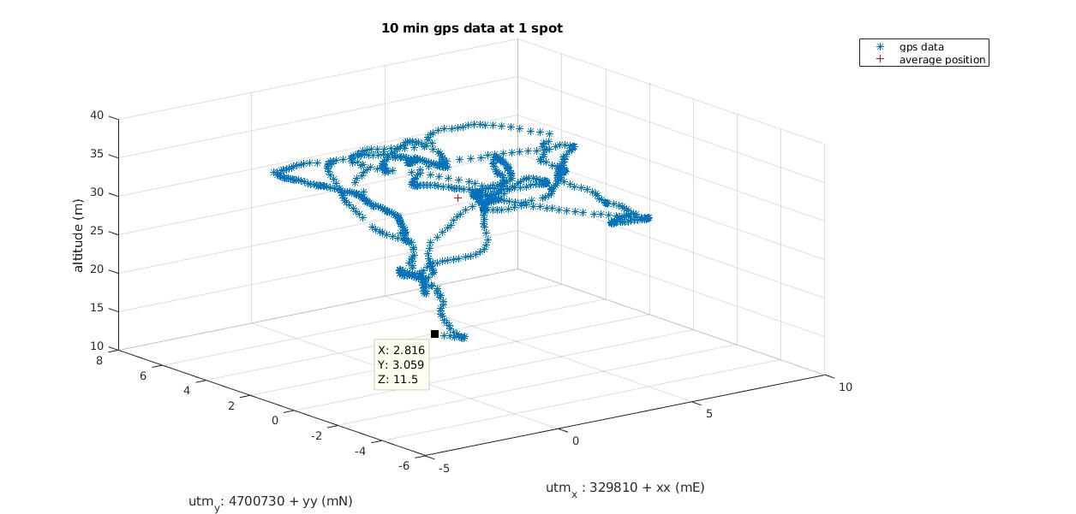

**Part2 – 1 min data collection while walking in a line.**

The first plot from Matlab shows both the gps data scatter and the trajectory of walking, which is approximately a straight line.

The plot shows I walked to the direction of southeast.

There are around 80 data points on the plot collected in around 1 minute with frequency of 1Hz.

The second graph shows the actual walking line on google map.

